TINGARA NETBALL CLUB

(Established 1969)
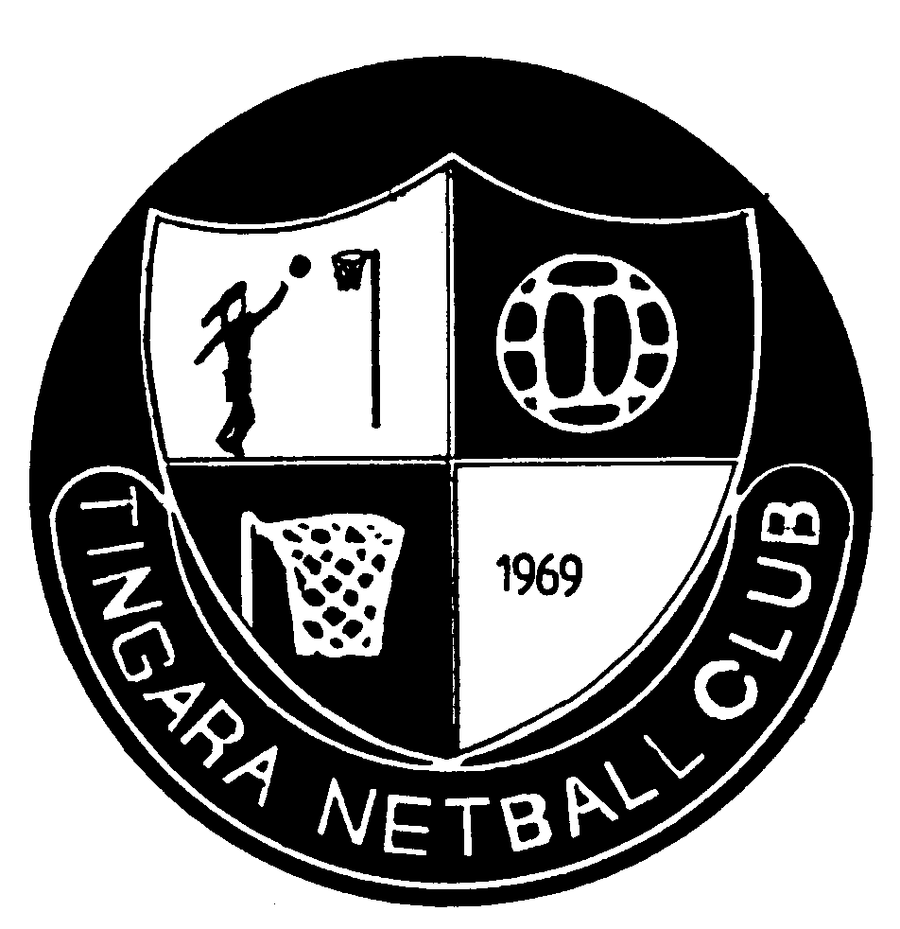

COACHES AND MANAGERS MANUAL 2016

Thank you for volunteering your time this season as a coach or team manager.

This Manual is designed to clarify your roles and associated responsibilities. Please read through this document. If you have any questions you can ask them at the coaches and managers meeting or contact a member of the Management Committee.

All the best for the 2016 season!

Tingara Netball Club
Management Committee

Contents
Description | Page
Tingara Mission Statement | 3
Duties of the Coach and Manager | 3
Scorer and Time Keeper | 4
Health, Safety and Injuries | 4
Additional Players | 4
Committee Support | 4
Training | 4
Player Positions, Captaincy and Court Time | 5
Information and Rules Booklet | 5
Dress Code for Players | 5
Equipment | 5
Information and Newsletters | 5
Coaching and Umpiring Information | 6
FNA Finals Rules | 6
Fairest and Best Voting Procedures and Team Trophies | 6
Feedback on Players’ Performance Levels | 7
Codes of Conduct | 7
Appendix I – Draft Letter from Coach | 8
Appendix II – Draft Letter from Manager | 10
Appendix III – Draft Scoring and Timing Duties Roster | 11

Tingara Mission Statement
At Tingara Netball Club, we strive to achieve success with integrity.
We seek to encourage a love of the game of netball from a young age and maintain that passion to senior competition. We strive to provide the best opportunity for each player, and team, to maximise their playing potential and balance this with our core values of sportsmanship, respect, commitment and team and club spirit.

Contact Lists for Coaches and Managers and Management Committee

Contact lists for the Tingara Management Committee and all coaches and managers will be distributed by email. Up to date copies are also available from the Coaching Co-ordinators at any time during the season.
Duties of the Coach
The following is a list of duties (in no particular order) that Tingara Netball Club would consider to be part of the “job description” of a team coach.
- Plan training sessions ensuring they are engaging, structured, purposeful and fun. Avoid players standing for too long waiting their turn.
- Be approachable and encourage open lines of communication within the team.
- Set a good example of appropriate attitudes and behaviour toward umpires, administrators and opposition teams.
- Guide team through an appropriate warm-up prior to game.
- Rotate substitutions evenly during the regular season.
- Allocate playing positions at games and make changes as necessary.
- Provide constructive feedback during training and games.
- Be mindful of your duty of care to all players at trainings and games, and take account of any medical conditions of particular players.
- Liaise closely with your team manager to ensure a smooth working relationship and clear understanding of roles.
- Utilise expertise and resources within the club as needed.
- Complete formal coach’s feedback form at completion of season. This information is VITAL for the following season’s grading.
Appended to this Manual is a suggested form of letter that coaches may wish to send to their players as soon as possible before the season starts. It will help to clarify team rules and the coach’s expectations for the season. Obviously, it can be amended as appropriate for individual coaches.
Duties of the Manager
The following is a list of duties (in no particular order) that Tingara Netball Club would consider to be part of the “job description” of a team manager.
- Collect and distribute all paper work to parents and players promptly.
- Liaise with the coach to check if there is anything that requires attention.
- Organise the scoring and timing roster for the season. See the notes below regarding these two positions.
- Ensure all player information, including additional player information, is completed on the scorecard before the commencement of the game.
- If the Tingara team is timing, check that the timer is working properly before you arrive at the game.
- Take responsibility for all team equipment at the game – eg gather up the warm-up and game balls, bibs, timers etc.
- If your team requires an additional player – refer to the section on ‘Additional Players’ for directions.
- The winning team must deliver the scorecard to the box located outside the FNA office.
- Ensure the Fairest and Best voting procedure is being followed. Refer to the relevant section of this Manual for directions.
- If you are playing at the 11.45am time-slot on grass or the 4pm time-slot on the hard courts, organise the return of goal post and protector to the storage area near the canteen ($25 non-return fine both teams).
- Provide a digital team photograph to the Management Committee at the start of the season.
- Note any medical conditions of players (as advised by the Club or the player or parents) and ensure that the coach is aware of these. If appropriate, liaise with parents to ensure that reasonable precautions are taken to assist in dealing with these medical conditions in the netball games and training environments.
- Other duties as may be directed by the coach or Management Committee from time to time.
If you need further clarification of your duties or the FNA regulations of the game, then please refer to the FNA Information Booklet and the FNA and Tingara websites. Doing these small tasks diligently will certainly make the coach’s task a lot easier.
Appended to this Manual is a suggested form of letter that managers may wish to send to their players and/or parents as soon as possible before the season starts. It will help to clarify team rules and the manager’s expectations for the season. Obviously, it can be amended as appropriate for individual managers.
Scorer and Time Keeper
Managers will roster the scoring and timekeeping responsibilities for the season. A sample roster is appended to this Manual. All scorers and timekeepers should be adults, who will stand or sit together in a central sideline position for the duration of the match and check on each other’s activities. Scorers and timekeepers (as well as umpires) are considered “match officials”. The first named team shall provide the official score card and scorer, and the other team the time clock and timekeeper.
Health, Safety and Injuries
All coaches and managers should be aware of the basic injury prevention, warm up/down and other health and safety information available on the Coaching, Umpiring and Injury Prevention page of the Club website.
Should an injury occur on the court at the game, the coach (or manager if the coach is not present) is to encourage the injured player and their parent/guardian to go to the First Aid rooms situated in the clubrooms at FNA, regardless of the severity of the injury. If a player chooses not to attend the first aid room, the injury is not recorded by FNA and insurance may not be paid. If an injury occurs at training, please contact the relevant Coaching Co-ordinator at the earliest opportunity. This can be done by email or telephone. Please also refer to the Tingara website for hints on injury management and physiotherapy.

Additional Players
When an additional player/s is required, it is Club policy to use players within Tingara first. IT IS IMPORTANT THAT THE COACH CONTACTS THE COACH OF A TEAM IN A LOWER GRADE TO REQUEST A REPLACEMENT PLAYER (rather than a player directly). If all avenues within Tingara have been exhausted, then a non-Club member can be approached to play under FNA’s Single Game Voucher system. When an additional player is used, that player must not be given more court time than a regular team members unless the regular team members are not able to play the position for which the additional player has been called upon to play.
The Coach has the responsibility of following the Single Game Voucher System as required by FNA. Please refer to the FNA Information Booklet for directions in this regard. Payment is not the responsibility of the non-Club member. The responsibility for payment will need to be made on a case by case basis, for example in the senior ranks; it might be reasonable for the senior player who cannot make the game to make the payment. The relevant Coaching Co-ordinator must be advised of any playing by a non-Club member at the earliest opportunity.
PLEASE REFER TO THE FNA INFORMATION BOOKLET REGARDING THE SINGLE GAME VOUCHER PROCESS.
Committee Support
You are welcome to contact the relevant Coaching Co-ordinator regarding any netball matter. Your enquiry or concern may be directed to an alternative Management Committee member if that person is better placed to manage the enquiry.
Training
Please:
- encourage players to advise you if they are unable to train.
- don’t change your training times unless you have 1st consulted the relevant Coaching Co-ordintor.
- don’t train at any venue other than Brentwood Primary School.
- ensure that you inform all players, designated training key holders etc. should for any reason you have to cancel training.
- don’t have someone train or supervise your team other than a coach, a specified parent or the manager and have a clear plan B organised just in case the coach cannot make it to training.
- Share courts with other teams fairly
- Arrange for players to return all equipment at end of training session
School Holiday Training
This is at the coach’s discretion. Please contact the designated key holder prior to holidays so you can make arrangements to have access to the equipment and lights. The key holders are identified on the coaches/managers list.
Wet Weather Training
Coach’s discretion applies, however please remember that netball is a winter sport.
Rotation of Positions, Captaincy and Court Time
All Grades
The coach and manager must ensure an equal rotation of captain’s role over the season
F, G and H grades
In our F, G & H grades (non-finals year groups), there is an expectation that all players will be rotated through all playing positions on a regular basis.

It is important for girls of this age to be exposed to all positions and avoid being 'pigeon-holed' to one or two positions. Emphasis should primarily be on general skill development that applies to all positions. Girls develop at different rates and at different ages, so it's important we be mindful of their long term netball participation so as to not stereotype, for example a tall, early developer as a GS or GK.

All players should receive even court time over the duration of the season. No one player should spend any longer on the sidelines than another - irrespective of perceived strength and weakness. This is club netball and all players are considered equal during the regular season.

We ask that all coaches adhere to this throughout the season. It can be useful to keep a record of positions and quarters played so there can be no questions raised in regard to fairness. Please refer to our website for templates. http://www.tingaranetball.com.au/coaching-umpiring--injury-prevention.html

Junior E and above (including Seniors)
1. Use discretion with the rotation of players through positions.
2. Be fair with standing players out. Subject to item 3 below, you should attempt to give all players as equal court time as is reasonably possible.
3. In finals, all players should get to play at least one-quarter unless injured or ill.

FNA Information Booklet
On receipt of the FNA Information Booklet, please read it and make yourself aware of the relevant information. Season fixtures are on the FNA website. http://www.fremantlenetball.com.au/

Dress Code for Players

Tingara players must wear the Club uniform. Sports briefs are to be black and a full brief, no bikini’s, colours or G-strings will be worn. No jumpers are to be worn. The coach should address uniform offences with the player or parent as appropriate.
Jewellery
As per the FNA rules governing match play, no item of jewellery except a wedding ring and /or a medical alert bracelet, shall be worn. If either or both are worn, each shall be taped. This is in accordance with the Netball Australian Official Rules 1.4.3
Please note that ear-rings must be removed – no taping is allowed.
Equipment
A bag of equipment will be distributed at the Coaches and Managers Meeting. The bag must be returned to the Equipment Manager at the conclusion of the team’s season, with the bibs washed. Please refer to the handout provided in your equipment bag.
Information and Newsletters
All information for coaches, managers and teams will be emailed with newsletters and other important information.
Coaches and managers are reminded of the importance of distributing information to players and parents in a timely fashion as some of this information may have important deadlines.
Coaching Information
Please refer to the FNA and Tingara websites for information on coaching courses that are available this season. http://www.fremantlenetball.com.au/coaching.htm
Tingara coaches wishing to access a coaching program with financial support from the Club must first approach the Coaching Co-ordinator. We regret that a participant cannot be reimbursed if Club approval was not obtained prior to enrolment or attendance at a coaching course.
Please refer to the Tingara website for assistance on coaching strategies etc. There are also coaching booklets available through the Junior Coaching Coordinator.
Please forward any requests/ideas for coaching clinics to the Coaching Coordinator.
Umpiring Information
FNA require the Club to provide an umpire for each game for each team registered in the Fremantle competition. Tingara has adopted a paid umpiring system for all games. The roster is organised by the Club’s Umpiring Co-ordinator, Keryn Rae. Please direct all umpiring enquiries to Keryn.
FNA Finals Rules
Please note that there are special FNA rules relating to player eligibility for finals (eg permits for players). Please refer to the FNA Information Booklet. If you have any further queries, please refer to the relevant Coaching Co-ordinator.
Fairest and Best Voting Procedures and Team Trophies
The following procedures apply for junior grades A-E, under 17, under 19 and senior teams. Please note that there are no fairest and best trophies for the junior F-H grades. All members of these young teams receive participation trophies.
The Fairest and Best trophy is awarded to the player in each team judged as the fairest and best player over the course of the season by 1 or 2 judges at each game on a 3, 2, 1 basis as voted by each judge. The judge or judges may consist of the coach, manager or parents (on a rotational basis) or any combination of these, at the discretion of the coach and manager of each team as determined at the start of each season.

For Tingara teams comprising of all adults or a majority of adults, the players and/or coach may elect an alternative method of choosing the Fairest and Best player for their team, and this method MUST be agreed prior to the start of the season.
In each team bag, there will be 3 white envelopes, one for each round, with 5 smaller, yellow envelopes in them. At the end of each game, the person or persons assigned to pick the fairest and best players is/are to confidentially write down the names of the three players whom they considered performed best that game, and hand those votes to the team manager.
At the last game of each round (ie there are 3 rounds of 5 games each), the managers are to place the yellow game envelopes inside the white envelope and place the white envelope in the fairest and best box, which you will find under Tingara’s umpiring table near the FNA office. This box will be collected at the end of the 4pm game and will not be put out again until the end of the next round, so please ensure all votes are handed in. If you do not manage to hand in your votes, contact the Tingara Record Keeper in the week following the game. At the end of the season the votes will be tallied and the Fairest and Best trophy will be awarded accordingly.

There is a 2nd player trophy awarded for each team. This trophy is awarded at the discretion of the coach of each team to either of:
- the player in each team judged as the runner-up fairest and best player as voted by the judges over the season; or
- the player who in the coach’s view is worthy of receiving a trophy to recognise that player’s courage, determination, consistency, teamwork or other special characteristics over the course of the season.

Essential Feedback on Players’ Performance Levels

To assist with the grading processes for the following season, Tingara will be seeking formal feedback from all coaches on the performance and skill levels of all players at the end of this season. Coaches will be contacted at the season end to complete a brief written assessment for each player. It is essential to treat this process with due attention and consideration. Failure to submit a coaches feedback form makes the grading process for the following year less comprehensive.

In addition, whilst it is most appropriate that coaches give feedback to individual players and/or their parents during and at the end of each season, it is most important that coaches do not comment on the prospects of individual players for grading in the following year. This may raise false expectations, particularly where coaches do not have the big picture of the strength of the entire grading group for the following year.
Codes of Conduct
Please ensure that all Codes of Conduct are adhered to.
Tingara endorses the Fremantle Netball Association (Inc.) Codes of Conduct. The Players, Coaches, Parents and Spectators, and Administrators codes of conduct are outlined in the FNA Information Booklet. They are also on the Tingara and FNA websites.
As a member of the Tingara community, coaches and managers may find themselves at the scene of minor to serious breaches of one or more of the Codes of Conduct. Accordingly, please be aware of the following:
- The Club encourages all of its committee members, coaches and managers to take responsibility for disarming a situation when breaches occur.
- This may take the form of a quiet word to the offender through to requesting FNA assistance at the scene.
- If a Tingara player is acting in a manner that places into disrepute the Club or the game, that player should be removed from the court and allowed time to settle down or not be placed back on the court, as each case may require.
- Of course we ask you to use your discretion in such situations and not to put yourself or anyone else in harm’s way.
- If a breach is taking place and you need assistance, please ask one of the teams supporters to go to seek a Tingara Committee member for assistance. It is possible to request the FNA announcer to call for a Tingara official (Committee member) to attend a court where a breach is underway.
- Only in exceptional circumstances should assistance from FNA be sought before that from a Tingara Committee member.
- If a member or parent of Tingara is in breach of any of the Codes of Conduct the Management Committee must be informed. Please contact a member of the Management Committee as soon as possible.
- The Executive Committee of Tingara has the right to enforce disciplinary actions should any of the Codes of Conduct be breached.
APPENDIX I

Draft Coach’s Letter:

Dear Girls and Parents,

Welcome to the 2015 netball season at Tingara. My name is xxx and I will be your coach this season. I am looking forward to having a great season together striving to provide the best opportunity for each player and the whole [enter your grade if available] team.

I have played netball for xx years and have coached for xx years. I am looking forward to using my experience and knowledge of the game to maximise the potential of all players.

Training is an essential key to learning the skills to becoming a better player and to work as a team. If for any reason you are unable to attend training, or a game, it is essential you notify the manager or me as soon as possible by mobile phone or text. Please remember that netball is a winter sport and rain is not an excuse for not being able to attend training (hail and lightening are negotiable!)

I also ask that at least 1 or 2 parents are able to stay for each training session so we can ensure that we can act appropriately in the event of an injury or extenuating circumstances. The team manager will discuss this responsibility with you. It is imperative that everyone within the Club is aware that we, as coaches, are not ‘babysitters’ and require the assistance of all members and parents to assist and volunteer their time to ensure that Tingara is successful and safe.

If you have any queries or questions regarding training or games then please don’t hesitate to contact me.

Most of all I can’t wait to get to know you all and, above all, have fun on and off the court throughout the 2015 Season.

GO TINNIES!!!
Coach’s name and contact numbers and email address
(and possibly name and contact details for Manager if available).

P.S I have attached the following for your reading:

1. “10 Ways to Be a Good Sport”.
2. The FNA Players’ Code of Conduct
3. The FNA Parents’ Code of Conduct

10 Ways to Be a Good Sport
Here are some ways that you can show others what good sportsmanship is all about:
- Be polite to everyone you’re competing against or playing with.
No nasty talk – which means not saying mean things while you’re in the middle of a game.
- Don’t show off. Just do your best. If you’re good, people will notice….
- Tell your teammates and opponents “good game or well done!” whether you’ve won or you’ve lost.
- Learn the rules of the competition. Show up for training and games on time.
- Respect the other team or competitors efforts.
- Don’t argue with the umpire or officials if you don’t agree with his or her call. If you don’t understand a certain call (or rule), wait until the next break, or after the game to ask your coach or for the official to explain it to you.
- Don’t make up excuses or blame a competitor or teammate when you lose. Losing is just another part of the game.
- Understand that everyone needs to sit out so that all team members get to share the court time.
- Play fair, don’t cheat.
- Cheer for your teammates whether you are winning or losing, you could inspire a big comeback or a bigger win!
FNA Players Code of Conduct
- Play by the rules, play fair and "in the spirit of the game of Netball".
- Never argue with an official. If you disagree, have your captain, coach or manager
approach the official during a break or after the competition.
- Control your temper. Verbal or physical abuse of officials or other participants,
Deliberately distracting or provoking an opponent is not acceptable or permitted.
- Work equally hard for yourself and your team.
- Be a good sport. Applaud all good plays, whether by your team or the opposition.
- Treat all players, as you would like to be treated. Do not interfere with, bully or take
unfair advantage of another player.
- Co-operate with your coach, teammates and opponents.
- Respect the rights, dignity and worth of all participants regardless of their gender,
ability, cultural background or religion.
- Enjoy the sport in every possible way, display modesty in victory and graciousness in
Defeat.
- Thank the opposition and officials at the end of the game.

FNA Parents Code of Conduct
- Encourage players to participate if they are interested, do not force them.
- Encourage players to always participate according to the rules and the umpiring
Decisions.
- Focus on the player and teams’ efforts and performance rather than winning and
Losing.
- Never ridicule or yell at a child for making a mistake or losing a game.
- Remember that children learn best from example. Applaud/appreciate good
performances and skilful plays by all participants.
- Support all efforts to remove verbal and physical abuse from the game.
- Respect officials’ decisions and teach players to do likewise.
- If you disagree with an official, raise the issue through the appropriate channels
rather than questioning the officials’ judgment and honesty in public.
- Show appreciation of volunteer coaches, officials and administrators.
- Demonstrate appropriate social behaviour by not using derogatory language,
harassing players, coaches or officials or interfering with the progress and /or
conduct of a game.

APPENDIX II

Draft Manager’s Letter:

Dear Tingara Players, Families and Supporters,

I would like to take this opportunity at the beginning of the 2015 Season to introduce myself. My name is ……, I have volunteered to be the Manager for the Tingara [insert grade if known] team. My daughter is ………

I have attached some of the necessary information for the 2015 Netball Season including Fixtures, Rosters for Timing/Scoring/Snacks, a map of the courts and contact information.

Games are held each Saturday and the 2015 Season Commences on 2 May. We have a bye on the 30 May and 11 and 18 July. The final regular game is on the 30 August. For teams who have finals, the first semi final is 5 September, the preliminary final is on 12 September with the grand final on 19 September.

Our games start at ……, however is it essential that the girls arrive at least ….. minutes before the game for their warm up with our wonderful coach, [insert name]. As soon as you are aware that your daughter is unable to attend a game (or a training session), please let me know.

It is an FNA requirement that each week, each team provides a time-keeper or a scorer. I have allocated these roles and prepared a roster. Could you please check the attached roster and note the weeks you are required to help. If you are unfamiliar with these roles, please don’t hesitate to ask me so I can offer you any assistance required to ensure you are comfortable with these positions. If you are unable to be at the game when you are rostered to be a timer or scorer, again, please let me know asap so we can arrange a suitable swap.

The first named team shall provide the official score card and scorer, and the other team the time clock and timekeeper. It is an FNA requirement that they shall stand together and check both the time and scores with each other. It is also the responsibility of the winning team to ensure that the scorecard is handed in to the FNA office each week. Please note that I will bring the equipment bag each week to the game, which contains the score cards and the timer.

To avoid over complicating the roster, and to keep it simple, I ask that the family allocated for the ‘duty’ that week please provide a ‘snack’ for the team. We can discuss, as a team, what the majority of the team would prefer eg oranges, lollies, fruit or agreed snacks at our early training sessions, before the season commences.

If you would like to track the team’s progress throughout the season, or if you require any other relevant information (including fixtures) this can easily be accessed at the Club website (go to the team fixtures and results page) at www.tingaranetball.com.au

Please note that the coach is volunteering her time and energy (including many hours of preparation and thought) for our daughters 2015 netball season at Tingara. Without their skills and assistance, we would not be able to function as a netball club. As such, I ask that you offer your encouragement and support.

Please direct any rostering or any other “administrative” questions to me so we can allow our coach to concentrate on the girls’ training sessions and games. Of immediate importance are any dates that you know in advance that your daughter will not be able to play or attend training sessions.

I am looking forward to a fabulous season with you and all the girls and would like to say “GO TINNIES”….

Kindest regards

Manager’s name and contact details including mob and email
APPENDIX III TINGARA NETBALL CLUB - SCORING AND TIMING DUTIES ROSTER

Team:

Coach: Phone No: Mobile:

Manager: Phone No: Mobile:

Each week our team is required to provide a scorer or a timer. A roster has been drawn up, but if your rostered day doesn’t suit you, please see me and we can arrange a change! Thank you!

Game No. | Date | Name | Score/  Time | Court # | Time | Opponents | Comments
Round 1
1. |  | a | Time
2. |  | b | Score
3. |  | c | Score
4. |  | d | Score
5. |  | e | Time
Round 2
6. |  | f | Score
7. |  | g | Time
8. |  | h | Time
9. |  | a | Time
10. |  | b | Score
Round 3
11. |  | c | Time
12. |  | d | Score
13. |  | e | Score
14. |  | f | Score
15. |  | g | Time

